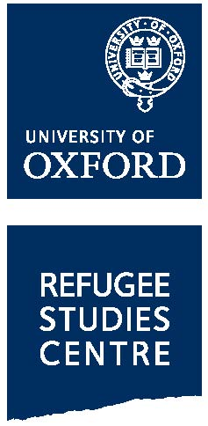

Palestine Refugee and International Law Short Course 2017
10 – 11 March 2017
REF: (for office use only)

APPLICATION FORM

⎯⎯⎯⎯⎯⎯⎯⎯⎯⎯⎯⎯⎯⎯⎯⎯⎯⎯⎯⎯⎯⎯⎯⎯⎯⎯⎯⎯⎯⎯⎯⎯⎯⎯⎯⎯⎯⎯⎯⎯⎯⎯⎯⎯⎯⎯⎯⎯⎯⎯⎯
First (given) name(s) Family name/surname

Title: Dr/Ms/Mr/Mrs/other (please specify)

Nationality Country of residence and work

Disability
⎯⎯⎯⎯⎯⎯⎯⎯⎯⎯⎯⎯⎯⎯⎯⎯⎯⎯⎯⎯⎯⎯⎯⎯⎯⎯⎯⎯⎯⎯⎯⎯⎯⎯⎯⎯⎯⎯⎯⎯⎯⎯⎯⎯⎯⎯⎯⎯⎯⎯⎯
Address for correspondence Tel

Email

⎯⎯⎯⎯⎯⎯⎯⎯⎯⎯⎯⎯⎯⎯⎯⎯⎯⎯⎯⎯⎯⎯⎯⎯⎯⎯⎯⎯⎯⎯⎯⎯⎯⎯⎯⎯⎯⎯⎯⎯⎯⎯⎯⎯⎯⎯⎯⎯⎯⎯⎯
Name and address of employer/organisation

Email

Present position Date appointed

⎯⎯⎯⎯⎯⎯⎯⎯⎯⎯⎯⎯⎯⎯⎯⎯⎯⎯⎯⎯⎯⎯⎯⎯⎯⎯⎯⎯⎯⎯⎯⎯⎯⎯⎯⎯⎯⎯⎯⎯⎯⎯⎯⎯⎯⎯⎯⎯⎯⎯⎯
Educational and professional qualifications (in brief)

⎯⎯⎯⎯⎯⎯⎯⎯⎯⎯⎯⎯⎯⎯⎯⎯⎯⎯⎯⎯⎯⎯⎯⎯⎯⎯⎯⎯⎯⎯⎯⎯⎯⎯⎯⎯⎯⎯⎯⎯⎯⎯⎯⎯⎯⎯⎯⎯⎯
Current work responsibilities relevant to this course, and other experience in refugee affairs

⎯⎯⎯⎯⎯⎯⎯⎯⎯⎯⎯⎯⎯⎯⎯⎯⎯⎯⎯⎯⎯⎯⎯⎯⎯⎯⎯⎯⎯⎯⎯⎯⎯⎯⎯⎯⎯⎯⎯⎯⎯⎯⎯⎯⎯⎯⎯⎯⎯⎯⎯
Personal statement in support of your application (please write 500-750 words)

Supporting information

To complete your application we would be grateful if you could please send us a copy of your:
- CV
- Highest level qualification
- Scan of your ID (e.g. a passport) as soon as possible

If your first language is not English, or if your first language is English but you are not a national of the UK, Ireland or a majority English-speaking country recognised by UK Visas and Immigration (UKVI), you must supply suitable evidence that you have reached the relevant higher or standard level before any offer of a place can be confirmed. The requirement to provide English language test scores may be waived in cases where you have successfully completed or are currently completing a degree or post-graduate level course that is: full-time, at least nine months long, undertaken at a recognised institution where the medium of instruction and assessment throughout the course is entirely in English.

